Q1.

Let X1,X2,……be independent random variables that are uniformly distributed over[-1,1].

Show that the sequence Y1,Y2,……converges in probability to some limit, and identify the limit, for each cases:

(a) Yn=Xn/n

(b)Yn= ${(Xn)}^{n}$

A1.

(a)For any ε>0, we have P($\left|Yn\right|$ >ε)=0 (by convergence in probability),

for all n with 1/n <ε , so P($\left|Yn\right|$ >ε)=P($\left|Xn\right|$ >n\*ε)=P($\left|Xn\right|$ >1) 🡪0

(b) For all ε $∈$ (0,1) we have

P($\left|Yn\right|$ >ε)= P(${\left|Xn\right|}^{n}$ >ε)= P(${Xn>}^{1/n}$) + P(${Xn<-}^{1/n}$) = 1- ${}^{1/n}$

When n is large enough P($\left|Yn\right|$ >ε)🡪0

Q2.

Before starting to play the roulette in a casino, you want to look for biases that you can exploit. You therefore watch 100 rounds that result in a number between 1 and 36. and count the number of rounds for which the result is odd. If the count exceeds 55, you decide that the roulette is not fair. Assuming that the roulette is fair, find an approximation for the probability that you will make the wrong decision.

A2.

Let S be the number of times that the result was odd, which is a binomial random variable, with parameters n = 100 and p = 0.5, so that E[X] = 100 · 0.5 = 50 and $σ_{S}= \sqrt{100*0.5*0.5}= \sqrt{25}=5$. Using the normal approximation to the binomial, we ﬁnd P(S > 55) = $p(\frac{s-50}{5}- \frac{55-50}{5})$ 1 − Φ(1) = 1−0.8413 = 0.1587. A better approximation can be obtained by using the de Moivre-Laplace approximation, which yields P(S > 55) = P(S ≥ 55.5) = $p(\frac{s-50}{5}- \frac{55-50}{5})$ ≈ 1−Φ(1.1) = 1−0.8643 = 0.1357.

Q3.

During each day, the probability that your computer's operating system crashes at least once is 5%, independent of every other day. You are interested in the probability of at least 45 crash-free days out of the next 50 days.

Find the probability of interest by using the normal approximation to the bino­mial.

A3.

Let S be the number of crash-free days, which is a binomial random variable with parameters n = 50 and p = 0.95, so that E[S] = 50 \* 0.95 = 47.5 and σ = $\sqrt{50*0.95*0.05}$ = 1.54. Using the normal approximation to the binomial, we find P(S ≥ 45) = P( $\frac{S - 47.5}{1.54}$ ≥ $\frac{45- 47.5}{1.54}$) ≈ 1 − Φ(−1.62) = 0.9474 = Φ(1.62)

A better approximation can be obtained by using the de Moivre-Laplace approximation, which yields

P(S ≥ 45) = P(S > 44.5) = P( $\frac{S - 47.5}{1.54}$ ≥ $\frac{44.5- 47.5}{1.54}$) ≈ 1 − Φ(−1.95) = 0.9744 = Φ(1.95)

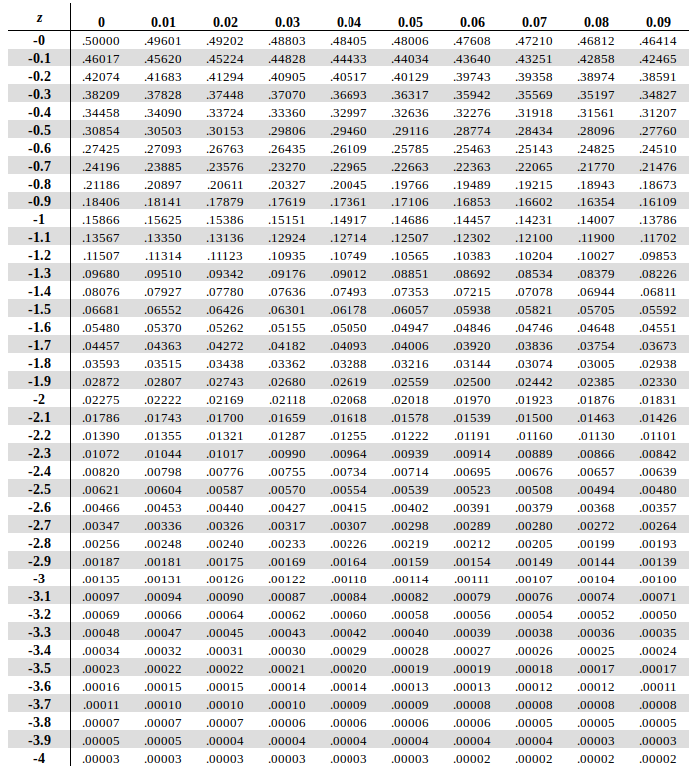

Q4.

Assume knowing that the amount of products manufactured from the factory in one week is a random variable, and its expected value of the products is 50 pieces.

1. what is the tightest upper bound we can say from the amount of products manufactured this week being greater than 75 pieces by Markov’s inequality?
2. If we know the variance of products manufactured this week is 25. What can we say about the probability of the products’ amount manufactured between 40 pieces to 60 pieces?

A4.

1. From Markov’s inequality
$$P\{ X>75 \}≤\frac{E\left[X\right]}{75}=\frac{50}{75}=\frac{2}{3}$$

2. From Chebyshev’s inequality

$$P\left\{\left|X-50\right|≥10\right\}≤\frac{σ^{2}}{{10}^{2}}=\frac{1}{4}$$

So

$$P\left\{\left|X-50\right|<10\right\}≥1-\frac{1}{4}=\frac{3}{4}$$

The probability of the products’ amount manufactured between 40 pieces to 60 pieces this week is at least 0.75.

Q5.

Suppose $X_{1},X_{2},X_{3}…X_{n}$ is a sequence of independent identically distributed random variables. The random variables are all uniformly distributed over $[0,1]$.

If the CDF of

$$\frac{2(\sum_{i=1}^{n}{X_{i})}-n}{\sqrt{n}}$$

converges to the CDF of a normal distribution of mean 0 and variance d, namely $N(0,d)$. What is the value of d ?

A5.

We first compute the mean and variance of the sequence $X_{1},X_{2},X_{3}…X_{n}$.

Since they are uniformly distributed over $[0,1]$. The mean and variance are $\frac{1}{2}$ and $\frac{1}{12}$ respectively.

From central limit theorem, we know CDF of

$$\frac{(\sum_{i=1}^{n}{X_{i})}-\frac{n}{2}}{\sqrt{\frac{n}{12}}}$$

Converges to CDF of $N(0,1)$.

In other words,

$$\frac{(\sum_{i=1}^{n}{X_{i})}-\frac{n}{2}}{\sqrt{\frac{n}{12}}} \underset{→}{d} N(0,1)$$

Simplify the expression,

$$\frac{2(\sum_{i=1}^{n}{X_{i})}-n}{\sqrt{n}}=\frac{2}{\sqrt{12}}\left(\frac{(\sum_{i=1}^{n}{X_{i})}-\frac{n}{2}}{\sqrt{\frac{n}{12}}}\right) \underset{→}{d} \frac{2}{\sqrt{12}}N\left(0,1\right)=N\left(0,\frac{1}{3}\right)$$

Therefore, $d=\frac{1}{3}$